CENWP-OD-B 08 August 2023

MEMORANDUM FOR THE RECORD

SUBJECT: 23BON076 MFR AFF Valve 15 Pacific Lamprey and Sockeye Mortalities

On the morning of 07 August, Columbia River Inter-Tribal Fish Commission (CRITFC) Biologists notified Bonneville Project Biologists of one Pacific Lamprey mortality and one Sockeye salmon found on the Valve 15 trash rack in the Adult Fish Facility (AFF). The fish were scanned for PIT tags, inspected, and returned to the river.
#1
- Species – Pacific Lamprey (Entosphenus tridentatus)
- Origin – Unknown
- Length – 63.5 cm
- Marks and tags – None
- Marks and Injuries found on carcass – General decay
- Cause and Time of Death – Unknown
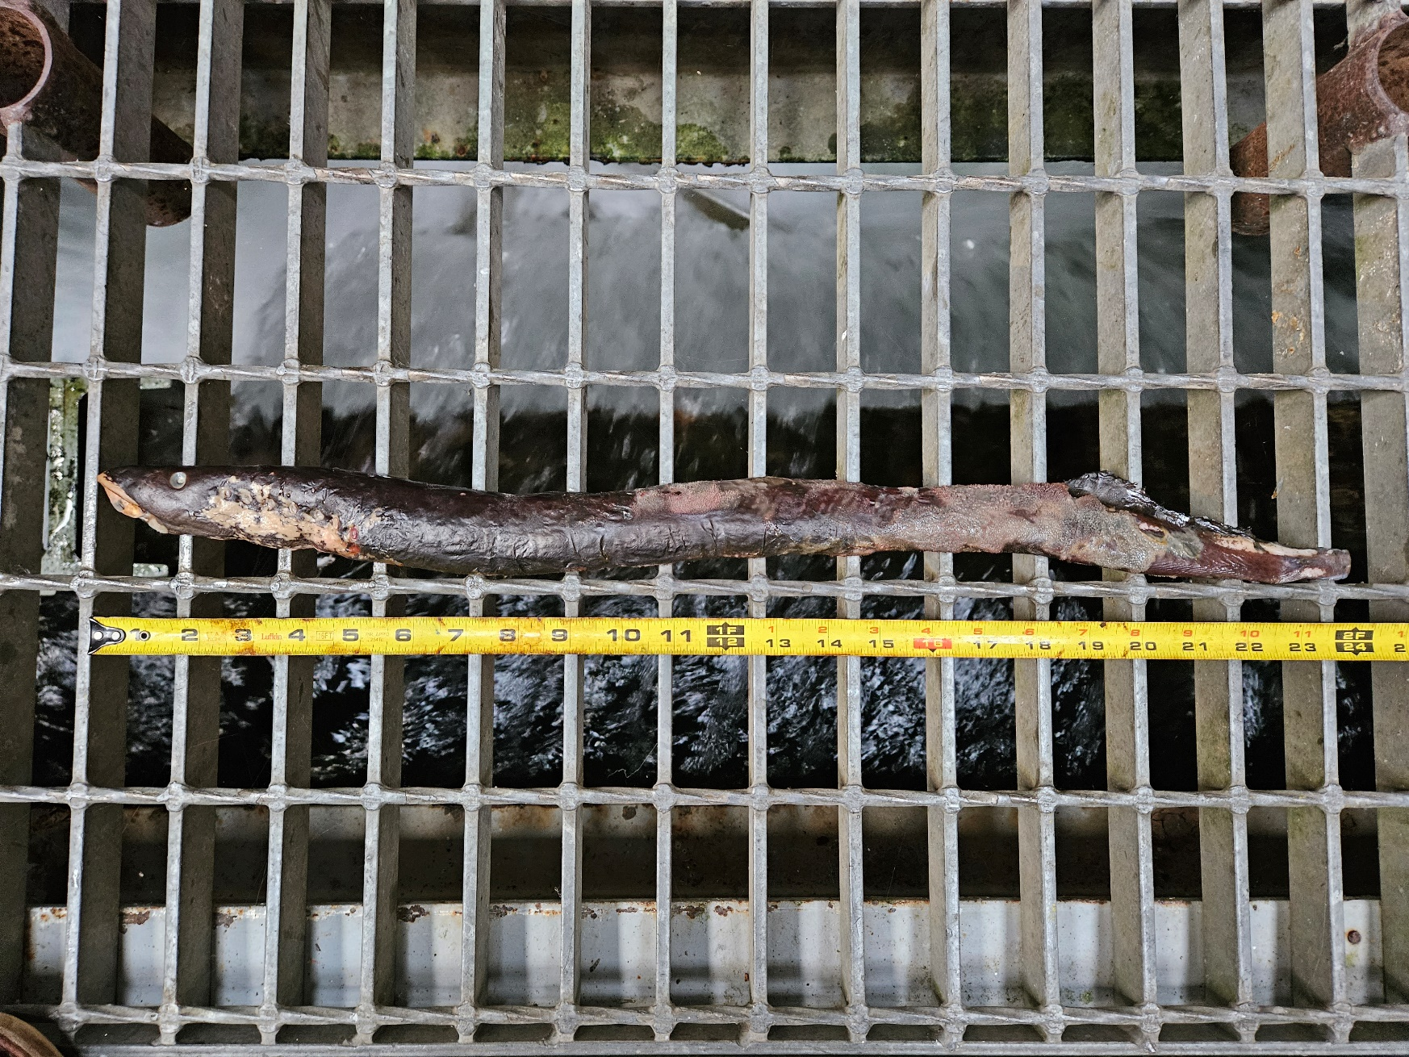
- Future and Preventative Measures – None

#2
- Species – Sockeye Salmon (Oncorhynchus nerka)
- Origin – Unknown
- Length – 58.4 cm
- Marks and tags – Adipose fin clip, no PIT tags
- Marks and Injuries found on carcass – General decay
- Cause and Time of Death – Unknown
- Future and Preventative Measures – None
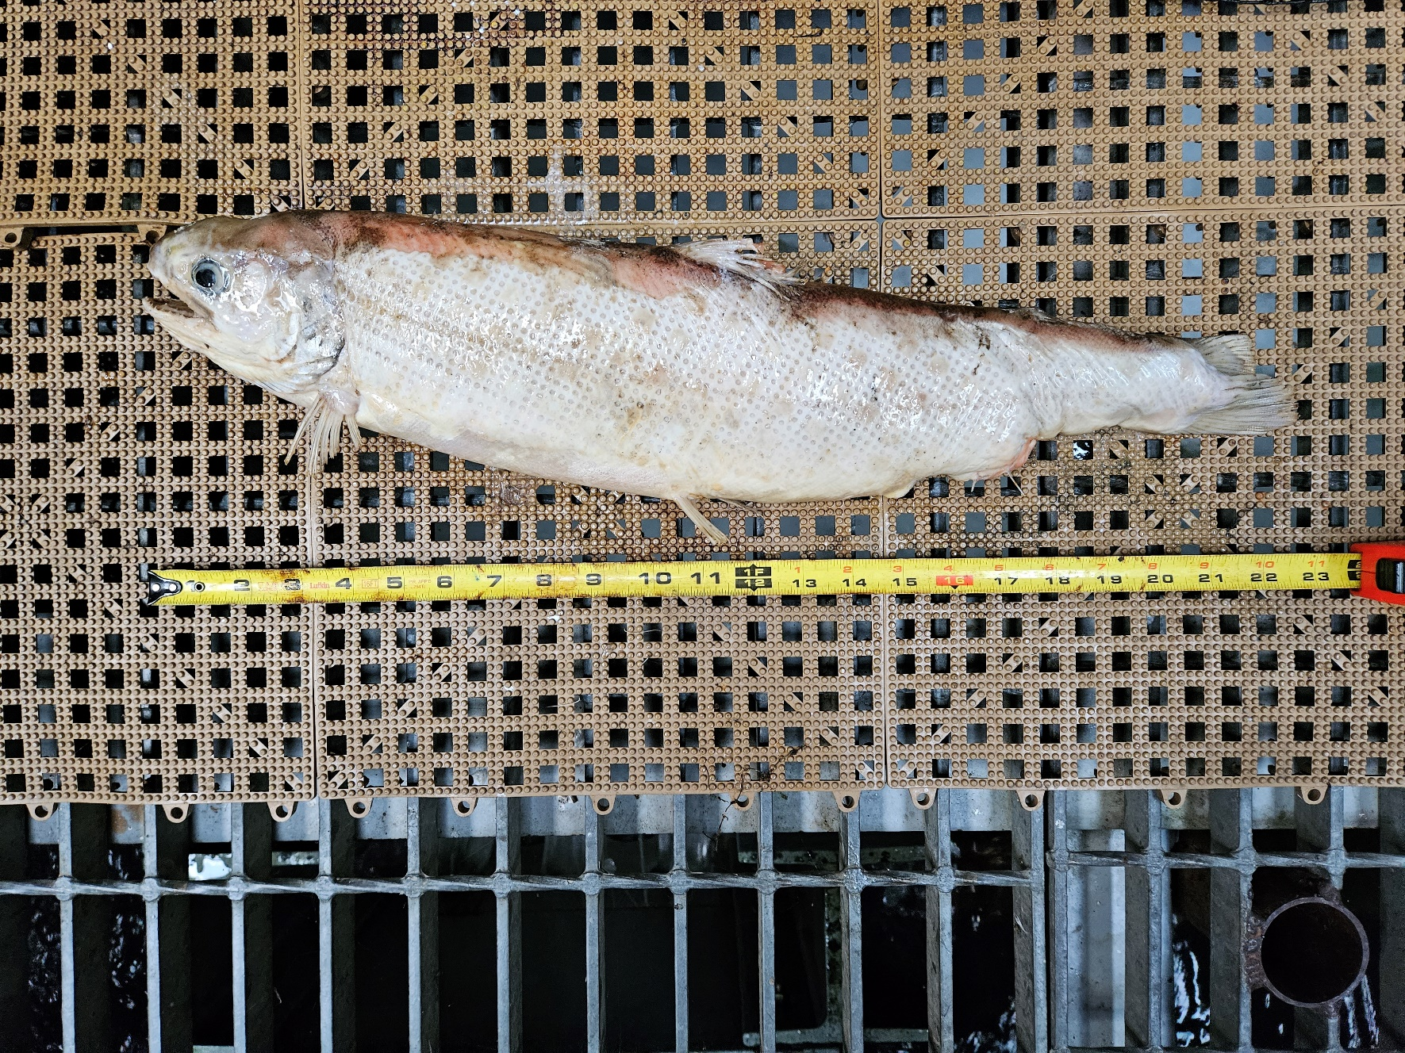
Sincerely,
Bonneville Project Fisheries

